Umatilla County Fire District #1

MCI Plan implemented February 2013

Review Date: 2/2016

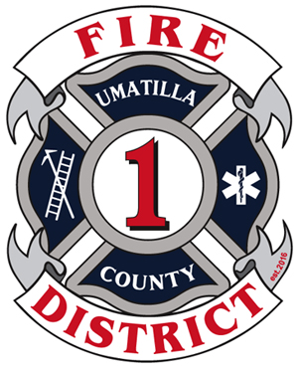

# Contents

Objectives 1

Scope 2

Incident Command 2

Command Post Functions Include: 2

Staging Areas 3

Medical (EMS) Branch 3

Triage 3

Treatment 5

Transport 6

MCI Kit 6

# Task Cards

Incident Commander Checklist 8

Medical (EMS) Branch Director Checklist 9

Triage Unit Leader Checklist 10

Treatment Unit Leader Checklist 11

Transport Unit Leader Checklist 12

Patient Transport Log 13

# Resource Tables

Table 1 – Resource Contact List 14

Table 2 - Hospital Resource List 14

Table 3 - Air Ambulance 15

Table 4 - Fire & EMS agencies (Umatilla Co. and nearby) 15

# Objectives

1. To prevent as many deaths and disabling injuries as possible during a mass casualty incident (MCI).
2. To provide a framework for triage, treatment, and transport for victims of a MCI.
3. To ensure safe and efficient use of resources.
4. To ensure the safety of all responding personnel.

# Scope

Coordinate a response of many different types and kinds of resources to an incident in our local response area that would overwhelm the local health care and/or EMS systems.

The first unit on-scene will notify medical control and dispatch that this incident is a MCI. This plan falls under the NIMS framework and the organizational structure is expandable/collapsible as needed. Under this plan, training is required at least once a year. It is acceptable and expected that this plan be used on smaller incidents that are not truly overwhelming, such as multiple patient MVCs, or incidents with other complexities.

Task Card/Checklists are to be kept in the MCI kit. To use this plan follow individual checklists found in the MCI kit.

# Incident Command

1. The Incident Command System (ICS) will be established by the first arriving unit on-scene. Overall command of the situation will be assumed and a command post established. Overall incident operations are under the direction of the Incident Commander (IC). Face-to-face transfer of command is required when changing incident commanders.
2. Deploy MCI kit
3. Complete Incident Commander Checklist from MCI kit.
4. Don “IC” vest
5. Assign divisions/braches as not to exceed span of control. A medical branch or partial components of the medical branch should be a high priority during an MCI.
6. Ensure the safety of responders, the scene, and bystanders.
7. The Incident Commander will identify him/herself and give a brief report of the situation to dispatch. Initial radio report should consist of:
   1. The name of incident and identity of the Incident Commander.
   2. A brief size-up and declare a MCI.
   3. Exact location of the Command Post.
   4. Approach routes and staging areas.
8. The IC shall consider initially requesting an MCI unit (various MCI trailers and Umatilla Heavy Rescue 12) to facilitate getting the unit rolling early
9. Activate the Umatilla County EOC and/or UCFD1 Ops center.
10. Assign LZ Coordinator
11. Establish Decon or HazMat Branch when needed to decon patients

### Command Post

1. A location from which all operations are directed.

2. Unified Command should be considered. (as needed, such as a crime scene)

3. Law enforcement supervisor, Public Information officer and Safety officer will co-locate at the command post.

## EOC / UCFD1 Operations Center

The EOC for Umatilla County is activated through dispatch. UCFD1 operations center is located at UCFD1 Station 21 and is activated by contacting UCFD1 at 541-567-8822. Staffing the EOC/Ops Center will be instrumental in gathering resources and personnel. Staff will be able to call/text/page additional personnel, coordinate services, create shift rotations, and ensure other calls are handled. Attempts to staff station for additional calls should be made by any means that will be determined at the time of incident.

# Staging Areas

Establish Staging and assign Staging Area Manager

# Medical (EMS) Branch

Sometimes referred to EMS Branch, the Medical Branch Director is directly responsible for the following:

1. Coordinate with other ICS Branches and IC
2. Establish Medical Channel (as needed)
3. The following positions:
   1. Triage
   2. Treatment
   3. Transport
4. Ordering resources through the IC or resource officer
5. Establishing Ambulance Staging Area if different from main staging location
6. Accountability of Medical Personnel

# Triage

The Triage Unit Leader is responsible for ensuring initial and on-going triage during an MCI. In addition the Triage Unit Leader is required to complete the following:

1. Obtain and complete the Triage Unit Leader Checklist
2. Ensure all patients are tagged
3. Coordinate movement of triaged patients to other areas (work with Treatment and Transport Units). Use assigned crews to move patients
4. Coordinate and provide accountability for crews
5. Relay triage information up the chain-of-command

Simple Triage and Rapid Treatment (START) is the most universal triage method in the United States. Jump Start for pediatric patients is also widely acceptable. Umatilla County Fire District #1 will use current *START* (Figure 1) and *Jump START* (Figure 2) guidelines for initial triage. Initially all ambulatory patients are green. Leave black tagged patients in place when possible. Remember the Mnemonic *RPM (Respirations, Pulse, Mentation) 30-2-Can Do*. Ongoing triage will continue throughout the incident, including the treatment areas, up to the point of transport.

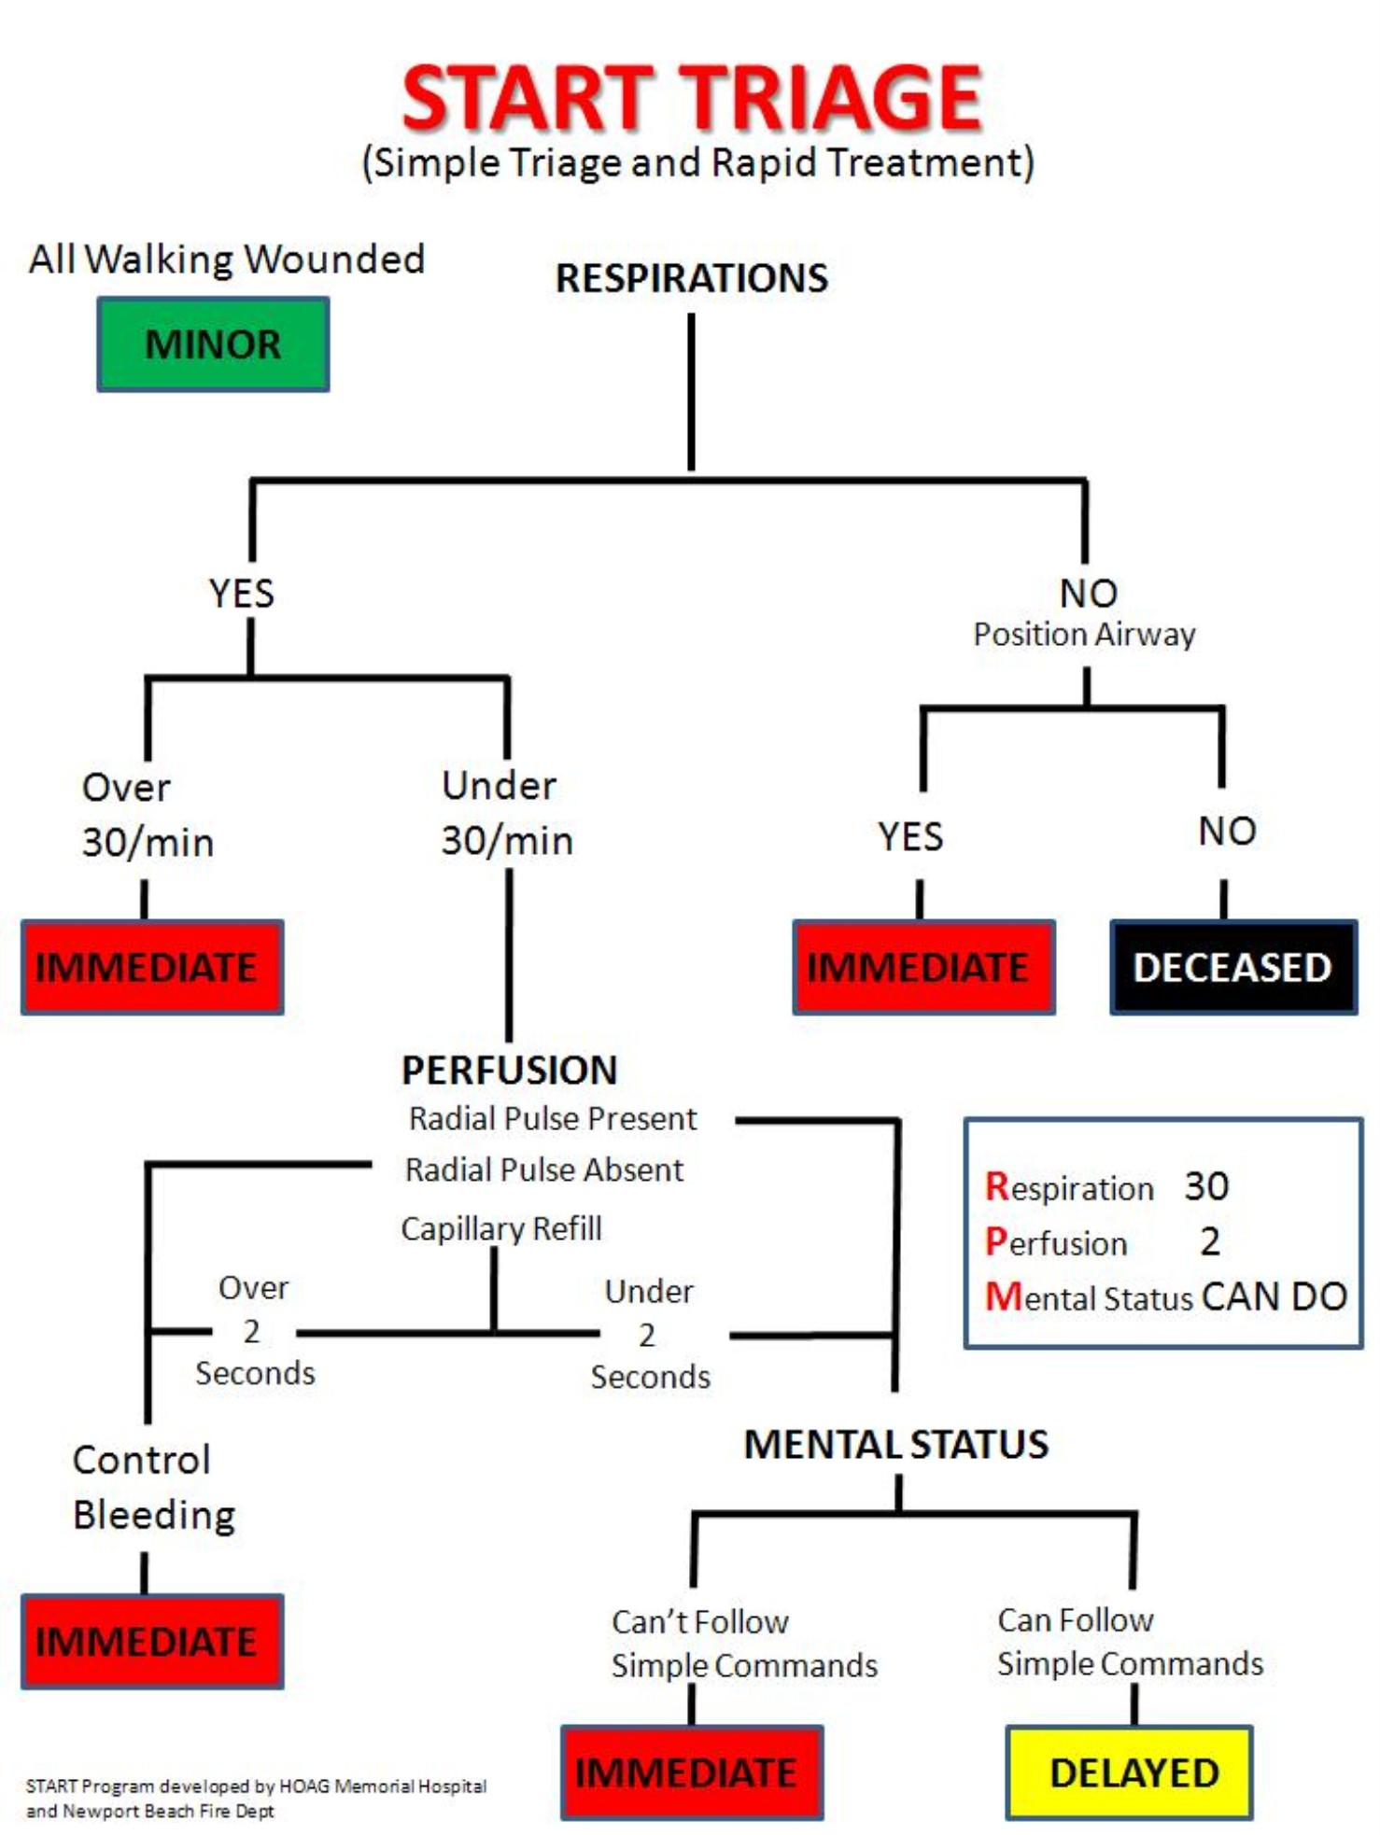

Figure 1

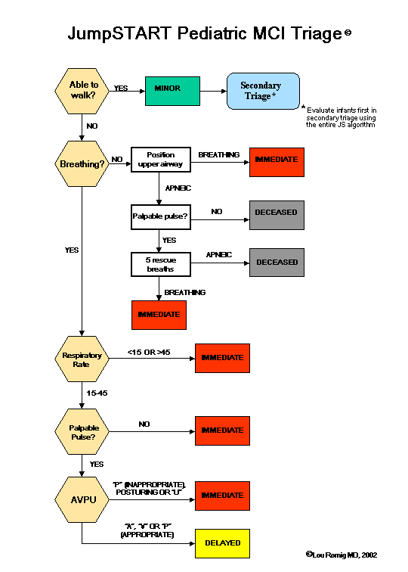

Figure 2

# Treatment

The Treatment Unit Leader manages the treatment area of an MCI including set up and coordinating the treatment area. The location for the treatment area will be determined at the specific incident scene, but should provide for easy access and egress both from where the patients are found and the transport areas. The treatment area shall be separated into three different zones consisting of red, yellow, and green. The zones need to be identified with cones, tarps, or colored tape. Personnel can be assigned to work in separate zones as needed. Accountability is the responsibility of the Treatment Unit Leader. The Treatment Unit Leader is required to obtain and complete the Treatment Unit Leader Checklist, including the following:

1. Designate & identify treatment area, including red, yellow, and green zones
2. Provide access with room to expand
3. Provide for environmental protection
4. Identify multiple treatment areas with geographic names (North/South, street name)
5. Order resources through Medical Branch Director
6. Identify entry point
7. Identify exit point or Loading zone
8. Ensure all patients have a triage tag
9. Coordinate patient movement to loading zone with Transportation
10. Provide accountability for personnel

# Transport

The transport Unit Leader is responsible for the coordination of transporting all patients to a medical facility. Transport should set up close to the treatment area and work closely with the Treatment Unit to determine the order of transporting patients from the scene. The Transport Unit is responsible for communicating with destination hospitals. **Individual medic units shall not contact the emergency department nor give a patient care report during an MCI unless their patient’s conditions deteriorate significantly during transport.**

1. Establish Loading Zone
2. Establish access/egress with Staging
3. Request resources from Medical
4. Supervise patient movement to loading zone (work with Treatment)
5. Monitor radio traffic (to estimate number of patients)
6. Establish communications with GSMC
7. Confirm MCI with GSMC
8. Provide total number of estimated patients to GSMC
9. Coordinate destinations
10. Provide report to destination hospital for each unit leaving the scene:
    1. Unit #
    2. Triage tag #’s
    3. Color/Categories
    4. Age/gender
    5. Brief* injury/treatment update
11. Confirm hospital destination with GSMC and record
12. Maintain Patient Transport Log

# MCI Kit

The MCI kit will be carried on BC21 and shall be removed and placed on another front line vehicle when BC21 is out of service or out of the area. Contents of kit will include:

1. IC vest and checklist
2. Medical Officer vest and checklist
3. Triage vest and checklist
4. Treatment vest and checklist
5. Transport vest and checklist
6. Red, yellow, and green tarps
7. Red, yellow, and green tape
8. Red, yellow, and green cones
9. Additional triage tags
10. Erasable markers/Grease pens
11. Pens
12. Clipboards X 6
13. Multiple Patient Transport Log
14. START or Jump Start laminated cards ?
15. Resource list (or keep in Ops/EOC?) *maybe both or all three?*

# Incident Commander Checklist

* Assume command on radio and face-to-face with previous IC (if applicable)
* Deploy MCI kit
* Don IC vest
* Identify the command post and establish unified command
* Identify Staging
* Assign staff positions and branches as needed (span of control)

# Consider activating EOC/Ops center for resource ordering (Resource Tables

* Table 1 – Resource Contact List)

# Medical (EMS) Branch Director Checklist

* Coordinate with other ICS Branches and IC
* Establish Medical Channel
* Establish the following positions:
  + Triage: _______________
  + Treatment: _________________
  + Transport: _________________
* Order resources through IC
* Establish Ambulance Staging Area if different from main staging location
* Accountability of Medical Personnel(?)

# Triage Unit Leader Checklist

* Ensure all patients are tagged
* Coordinate movement of triaged patients to other areas (work with Treatment and Transport Units)
  + Assign teams
* Coordinate and provide accountability for crews *assigned to you*
* Relay triage information up the chain-of-command
* Patient’s may have to be moved before triage
* Ongoing Triage

**Red\*** Immediate life threat. (rapid transport)

**Yellow\*** Delayed (1-3 hours)

**Green\*** Ambulatory (3 plus hours)

**Black\*** Dead (Move only if needed to reach other live patients, out of view)

# Treatment Unit Leader Checklist

* Designate & identify treatment areas, including red, yellow, and green zones
* Provide access with room to expand
* Provide for environmental protection
* Identify multiple treatment areas with geographic names

(North/South, street name)

* Order resources through Medical Branch Director
* Identify entry point
* Identify exit point or Loading zone
* Ensure all patients have a triage tag
* Coordinate patient movement to loading zone with *Transportation*
* Provide accountability for crews assigned to you

# Transport Unit Leader Checklist

* Establish Loading Zone
* Establish access/egress with Staging
* Request resources from Medical
* Supervise patient movement to loading zone (work with Treatment)
* Monitor radio traffic (to estimate number of patients)
* Establish communications with GSMC
  + HEAR
  + Phone (541-667-3533)
  + 450 mHrtz
* Confirm MCI with GSMC
* Provide total number of estimated patients to GSMC
* Coordinate destinations
* Provide report to destination hospital for each unit leaving the scene:
  1. Unit #
  2. Triage tag #’s
  3. Color/Categories
  4. Age/gender
  5. Brief* injury/treatment update
     + **Confirm hospital destination with GSMC and record**
* Maintain Transport Log

|  |  |  |  |  |  |
| --- | --- | --- | --- | --- | --- |
| Tag # | Unit # | Color | Injury | Destination | Report given |
|  |  |  |  |  | ☐ |
|  |  |  |  |  | ☐ |
|  |  |  |  |  | ☐ |
|  |  |  |  |  | ☐ |
|  |  |  |  |  | ☐ |
|  |  |  |  |  | ☐ |
|  |  |  |  |  | ☐ |
|  |  |  |  |  | ☐ |
|  |  |  |  |  | ☐ |
|  |  |  |  |  | ☐ |
|  |  |  |  |  | ☐ |
|  |  |  |  |  | ☐ |
|  |  |  |  |  | ☐ |
|  |  |  |  |  | ☐ |
|  |  |  |  |  | ☐ |
|  |  |  |  |  | ☐ |

Patient Transport Log Page ________

# Resource Tables

# Table 1 – Resource Contact List

|  |  |  |  |
| --- | --- | --- | --- |
| Resource | Contact | Emergenct Phone | potential uses |
| Mobile Command Post & Rehab Unit | Morrow Co. Dispatch | 541-676-5317 | Rehab, air, ICP |
| Umatilla County Search & Rescue | Umatilla Co. Dispatch | 541-966-3651 | ATV, Snowmobile, Command bus |
| Technical Rescue Team (Tri-Cities) | Benton Co. Dispatch | 509-628-2616 | Confined Space, Trench, High/Low Angle Rescue |
| Morrow Co. Search & Rescue | Morrow Co. Dispatch | 541-676-5317 | ATV ambulance, ATV |
| Red Cross |  | 541-276-1211  888-680-1455 | Shelter, Rehab |
| ODOT |  | 800-977-6368 | Equipment, Traffic |
| Umatilla Co. Emergency Management | Jack Remillard/duty phone | 541-310-0583 | EOC |
| Washington Demil Clinic |  | 541-564-7211 | Ambulance |
| UEC | On-call tech | 888-465-5071 541-561-5368 | Equipment, boom truck, Snow Cat |
| Wood Pecker Trucks | John Rehberge | 541-969-7984  541-276-5515 | Heavy duty wrecker, mobile service |
| Heller & Sons | Mike/Jim Heller | 541-571-1240  541-571-1241  541-561-4992 | Fueling |
| Benton Co. Dive Rescue | Benton Co. Dispatch | 509-628-2616 |  |
| Eagle Freightliner |  | 541-567-5677 | Heavy duty wrecker |
| NW Metal Fab |  |  | Crane |
| OERS |  | 800-452-0311 | USAR, HAZMAT, All hazard |
| Mid-Columbia Bus Company | John Griffith | 541-571-5075 541-571-5073 |  |
| Mobile Communications Unit | Shawn Halsey | 541-969-7592 | Mobile radio tower, hotspot |
| National Weather Service |  | 541-276-7832 |  |

# Table 2 - Hospital Resource List

|  |  |  |
| --- | --- | --- |
| Good Shepherd | Hermiston | 541-667-3533 |
| St. Anthony | Pendleton | 541-276-5121 |
| Pioneer Memorial | Heppner | 541-676-9133 |
| Kennewick General | Kennewick | 509-586-5887 |
| Kadlec | Richland | 509-943-5700 |
| Our Lady of Lourdes | Pasco | 509-546-2207 |
| St. Mary | Walla Walla | 509-525-2500 |
| Walla Walla General | Walla Walla | 509-527-8264 |

# Table 3 - Air Ambulance

|  |  |  |
| --- | --- | --- |
| Life Flight | 800-232-0911 or 208-367-3880 | Multiple rotor and fixed wing |
| NW Med Star | 509-532-7990 or 800-422-2440 | Multiple rotor and fixed wing |

# Table 4 - Fire & EMS agencies (Umatilla Co. and nearby)

|  |  |  |
| --- | --- | --- |
| Agency | Phone | Number of transporting units |
| Umatilla County Fire District #1 | 541-567-8822 | 5 ambulances |
| Pendleton Fire | 541-276-1442 | 4 ambulances |
| Tribal Fire | 541-276-2126 | 2 ambulances |
| Umatilla Fire | 541-922-3718 | 2 ambulances |
| Medic 400 | 541-566-3813 | 2 ambulances |
| Morrow Co. EMS | 541-481-2202, 541-676-2922 | 2 Heppner, 2 Boardman, 1 Irrigon |
| Echo Fire | 541-376-8118 (Chief) |  |
| Pilot Rock Fire | 541-379-1295 (Chief) |  |
| East Umatilla Co. Fire |  |  |
| Heppner Fire |  |  |
| Benton Co. Fire District 6 | 509-875-2029 | 2 ambulances |
| Boardman Fire | 541-481-3473 |  |
| Ione Fire |  |  |
| Lexington Fire |  |  |
| Irrigon Fire | 541-922-3133 |  |
| Milton Freewater RFPD | 541-938-8266 | 2 ambulances |
| Milton Freewater City | 541-301-4725 (Chief) |  |

|  |  |  |
| --- | --- | --- |
| Assembly areas | Contact | Phone |
| Pendleton Convention Center |  | 541-276-6569 |
| Hermiston Community Center | Debbie Pedro | 541-571-3155, 541-567-6151 |
| Hermiston Armory | Dan Hinkley, Dennis Corson | 541-561-2745, 541-910-6027 |
| Umatilla County Fair | Peggy, Fair Manager | 541-379-8321 541-561-5326 |
| Hermiston School Dist. | Mike Kay | 541-667-6019, 541-601-1545 |
| Pendleton School Dist. |  |  |

|  |  |  |
| --- | --- | --- |
| Logistics |  |  |
| Fire Corp – Hermiston | Robin Bozeman | 541-720-0027 |
| Fire Corp -Boardman | Robin Bozeman | 541-720-0027 |
| Jimmy Jons Portable Toilets | Jim | 541-571-2739, 541-571-3567 |
| Doug’s Septic Service |  | 541-938-7405,541-276-9202,541-564-6612,541-922-3684,541-910-7322 |

|  |  |  |
| --- | --- | --- |
| PIOs | Phone | Agency |
| Pat Hart | 541-571-3062 | HFES |
| Mike Roxbury | 541-314-8855 | UFD |
| Jodi Florence | 541-429-3566, 541-966-3607 | UCSO |
| Casey White-Zollman | 541-969-4787, 541-966-3115 | IMESD |
| Joani Bosworth | 541-966-3115, 541-276-8247 | National Forest Service |

|  |  |  |
| --- | --- | --- |
| State & Federal Agencies |  |  |
| FBI |  |  |
| ATF |  |  |
| Coast Guard |  |  |
| FEMA | 425-487-4610 |  |
| National Guard |  |  |
| FAA |  |  |
| EPA | 541-962-7218 |  |
| Army Corps of Engineers |  |  |
| National Weather | 541-276-7832 |  |
| NTSB |  |  |
| OERS | 800-452-0311 |  |
| OSFM HazMat Duty Officer | 503-589-2763 |  |